Statement of Work:

TalentOS AI Voice

Overview
The objective of this project is to collaborate with TalentOS to build Voice AI Agent to streamline applicant interactions, automate candidate screening and scheduling, and deliver a seamless experience that reflects Unifi’s commitment to innovation and operational excellence.
Nurix proposes the following AI solution:
- Voice AI Agent for candidate qualification and pre-screening.

Project Scope & Objectives
The Voice Agent will streamline candidate interactions, automate hiring workflows, and enhance overall efficiency, ensuring a seamless, engaging, and cost-effective recruitment journey for TalentOS.
Unifi & Affiliates (ERMC, Prospect)
This SOW covers the subsidiaries of Unifi - ERMC and Prospect only from a new AI Voice implementation.
Other customers of TalentOS
Other customers of TalentOS will be covered as part of a separate implementation plan / timeline. The usage cost for the TalentOS customers are captured in the commercial terms/structure in this SOW and will remain consistent/same.

Use Cases :
AI Voice Agent: Digital Recruiter
- Pre-screen applicants, Respond to FAQs about job roles, wages, and policies.
- Provide onboarding guidance (documents, procedures).

Objectives
- Candidate Screening / Inquiries: Answer FAQs about job roles, application status, or company policies. Screen candidates for job fit and behavioral competencies.

Solution Details

Proposed Solution
Conversational Understanding & Response
- Pre-screen applicants, capturing eligibility, qualifications, assessing relevant competencies and explaining job requirements
- Respond conversationally to FAQs, status inquiries, and role details
- Verify qualifications, and provide information strictly per Unifi, ERMC & Prospect’s SOPs
  - ERMC / Prospect’s SOP differs from Unifi only from the perspective of pay packages. Any complex implementation will need to be scoped separately
- Maintain natural, engaging interactions to enhance candidate satisfaction

SOP Adherence & Action Execution:
- Retrieve information from Avature CRM,, and other integrated systems.
- Identify the applicable SOP, review interaction history, and log correct dispositions.
- Initial scope covers screening, FAQs
- Incidents accurately tagged in Avature CRM with disposition categorization.
Call Management:
- Request human intervention in the scenarios:
  - The issue falls outside SOPs or is an edge case.
  - The candidate explicitly requests human support.
  - The requested language is not English
  - Candidate intent remains unclear within 30 seconds.
- Stick strictly to business context:
  - No competitor discussions.
  - No disclosure of confidential information.
  - Out-of-scope queries escalated to a recruiter.
Voice Modulation Support & Interaction Handling (Voice Agent only):
- Interruptions: Pause mid-response and either listen or prompt for clarification.
- Offensive Language: The Agent will never use or reciprocate inappropriate language.
- Language: English
- Supported Voices: English voices from the provider.
- Voice Selection: One default voice finalized before rollout.
- Modulation: Adjustable pacing and tone for a natural candidate experience.
Language Availability
The Voice Agents will be deployed in English. Nurix agrees that, once additional language capabilities (including but not limited to Spanish) are made generally available within the platform, TalentOS shall have the right to enable and use such additional languages based on the commercial model mentioned in Appendix A.
TalentOS will remain responsible for reviewing and approving any language-specific recruiting content, workflows, or compliance requirements prior to use with candidates.
Post-Agent Actions & Data Processing:
- Log, transcribe, and securely store every conversation.
- Sync transcripts and summaries automatically into Avature CRM.
- Clearly provide – Final recommendation (Pass/Review) with reason, Summary of the call highlighting sections of the transcript which a human reviewer should review, full transcript of the call, audio file.
Voice Agent Workflow:
- Automated outreach and follow-ups via weblink and dialer (Twilio) for screening and updates. The same method followed for follow ups thereafter . For Web based AI Voice Agent embedded solution - Web page will be maintained by TalentOS. Needed parameters required to identify candidates will be passed by TalentOS. Nurix will give the script to be added on the webpage and trigger agent based on attributes passed
- Verification of candidate details with privacy safeguards before sharing information.
- Agent to adhere to the script and not procure info/connect to open source AI to enable standardized and unbiased review of each candidate AI to enable standardized and unbiased review of each candidate
- Personalized conversations covering job details, role expectations, wages, and FAQs
- Integration with two Avature instances for interaction logging, applicant attributes, and status updates.
- Conversation details of intent and outcomes logged in CRM.
- Dashboarding for monitoring performance, metrics, and analytics.
- Secure storage of recordings and transcripts for review or audit.
- Scalability: Supports 20 concurrent calls, expandable to 50 for seasonal peaks.
Evaluation:
- Result either pass or review
- Assessments will be legally compliant and done in an unbiased manner
- Assess the response based on any combination of keyword indicators being present (showing an understanding and appropriate response to the question) along with verb + adjective pairings to indicate whether they are answering positively or negatively.
- A short reasoning response for why a candidate was moved to review or pass will be provided
- Highlight timestamp or location in transcript that triggered the review or any concern
- AI Agent will not make final hiring decision for any candidate
End Results:
- Log, transcribe and securely store every conversation
- Need call transcript, audio and summary to populate in Avature under candidate profile. Nurix will provide a summary on each call of why the candidate achieved a “Pass” or “Review” result. The summary will be passed to Avature along with the transcript of the call.
English Language/Dialect Considerations:
- Will be able to recognize the context and variations of all major American English dialects- AAVE, Cajun English, Appalachian English etc. (to the extent supposed by base ASR models)
  - It must interpret double negatives (ex: “never don’t help” = positive)
  - It must avoid penalizing non-standard phrasing, accents, or grammar
  - Accept diverse phrasing styles
  - Tool should be familiar with slang terms and not negatively score its usage

- Commonly misused phrases that make sense with context, linguistic eggcorns should be recognized or at least not penalize candidates (Ex: “could care less”)
- Ensure the model does not equate “standard business English” with professionalism or job readiness
  - The tool must not evaluate candidates based on subjective factors like professionalism, intelligence, or communication style.
- Use NLP logic to capture modifier + verb pairings, such as "never + late", "don’t + help", and detect when negation flips the intended meaning.
Learning Loop: On a monthly basis Nurix will update the agent based on following inputs provided by TalentOS . Nurix expects TalentOS to provide the changes required (keyword list, library, flag phrases etc).
- Ability for TalentOS recruiter to give feedback when human recruiter disagrees with AI decision
- Track which flagged phrases are most often false positives/negatives and retrain.
- Monthly keyword list expansion based on real candidate phrasing.
- Build a library of synonyms/slang to cover natural speech
Such library will be provided by TalentOS and reviewed with Nurix on a monthly basis to make any changes
Quality Control and Audit:
- Quality control checks and audits would be conducted regularly by Nurix team
- Nurix will provide data export as well as conversational logs for TalentOS to conduct their audit. Data export to include all data required to meet Client compliance requirements.

TalentOS acknowledges that it is responsible for compliance with all hiring and employment-related laws and regulations in connection with the use of the AI Voice and Chat Agents, including OFCCP, EEOC, and any state or local requirements.
Nurix represents that its technology has been designed and will be maintained in good faith to support compliance by:
- ensuring secure data storage and transmission in accordance with industry standards (e.g., encryption in transit and at rest, SOC 2/ISO 27001 practices),
- maintaining accurate and complete logs, transcripts, and reporting capabilities sufficient for audit purposes,
- collaborating with TalentOS to implement updates and adjustments needed to align with evolving compliance requirements, and
- not introducing features or logic that would materially compromise compliance with applicable hiring regulations.
TalentOS remains responsible for configuring compliance-related parameters (including flagged bias terms) and for the interpretation and submission of any required regulatory reports. Nurix agrees to provide requested data exports and audit support within a commercially reasonable period, not to exceed five (5) business days from request, unless otherwise mutually agreed.

Project Governance
Defined KPI’s:
- Maximum call latency: P99 call latency will be within 5 seconds
- Planned Outage schedule: No planned outage schedules. Will be informed in advance when planned with a 7 day notice
- Availability (max unplanned outage per year) : -99.9%+
- Involuntary call disconnect rate attributable to system error (this also should be included in reports): <0.01%

Support Model:
- P0 (priority 0) incidents will be supported 24 * 7 with response time SLA of 4 hours
  - P0 incidents are of the nature of system outages, agent stopped working, etc. that has severe business disruption and AI Voice agent is not performing as designed
- 10 hours of additional support / month (no rollovers) is included in the model. Such support includes a) changes to interview questions, b) updates to phrases etc. These hours will not be consumed for large enhancements or new projects / use cases
- Professional services beyond 10 hours/month will be charged additionally

Change Management Process
- Future platform enhancements that are generally available will be communicated with advance timeline and provide the opportunity for the client to test & sign off prior to implementation at no additional cost.

Data Ingestion / Requirements
To ensure the successful implementation of the voice agents, the following resources and access are required from
- Systems API Access: Necessary for integrating AI voice agents with required systems (Internal CRM, Avature).
- SOPs and Guidelines: Share Standard Operating Procedures and call flows to align AI responses with company policies.
- Technical Documentation & Support: Any APIs or integration documentation and support related to data flow.

Reporting & Analytics
Reporting and analytics dashboard will be provisioned to track AI Voice and Chat Agent performance.

High-level metrics: At an overall level, the following should be available, such that the data is provided by disposition categories/intent & time period

Voice Metrics
  - Total Outbound Calls: Volume of outbound calls initiated by the candidates
  - Connected Candidate Calls: Number of calls successfully answered by candidates
  - Pass vs. In-review breakup: % and count of screened candidates by total candidates contacted
  - In Review Breakup should also detail the failed call reasons – i.e. disconnected, failure to understand, etc.
      - In-review breakup also includes human intervention requests
  - Average Call Duration: Mean time per completed call across dispositions
  - Abandonment Rate: Percentage of calls that ran through to a logical end (vs. dropped/hung up early)
  - Nurix to share raw data
  - Response Latency: Average AI response time (in milliseconds), benchmarked for conversational smoothness.
Conversational Analytics: For every voice conversation, the following should be available
  - Summary of conversation:
      - Candidate details (name, phone, role applied for)
      - AI-generated summary of interaction including key intent, outcome, and context (logged into Avature CRM)
  - Agent action:
      - Incident creation or intent captured by the AI at the end of conversation.
      - Data by disposition categories (e.g., FAQ resolved, interview scheduled, human handover)
  - Total interaction time: Conversation duration captured
  - Access to transcripts and recordings for every AI-handled conversation
  - The reports should be downloadable in CSV format
  - Nurix will assist in developing and maintaining System Performance and Audit Compliance dashboards as required. For purpose of clarity, Nurix will provide conversation data for such dashboards & TalentOS will develop, maintain the same

High Level Timelines
- This project will be executed over a timeline of 12-14 weeks for Unifi. Additional effort/timeline may be required for ERMC and Prospect and will be determined during project execution.

Acceptance Criteria & Sign-Off Process
- The AI voice agent will be integrated, passes UAT & is deployed as specified in the scope of this document
- Assumption: Timeline is dependent on timely availability of solution details, SOPs, call recordings etc. during the 1st week of the project
- The Client will formally sign off the solution has been built to meet SOW criteria prior to implementation.
- Nurix to maintain data protection standards that includes encryption in transit and at rest with TLS 1.2+ and AES‑256 or above. Nurix will use SSO, MFA, RBAC with least privileges and other tools to ensure TelantOS data is accessible by only authorized users.
- Nurix shall have the product made available maintaining their information security program aligned to SOC 2 Type II or ISO 27001.
- Recordings, transcripts, and other data stored at Nurix to have a retention default period of 180 days and must be configurable per state laws.
- Nurix processes to be GDPR compliant. Ensure that any PII data received are handled with SOC 2 Type II or ISO 27001 standards.
- No “The Client’s” data captured to be utilized to train any other ML models other than TelantOS ML models by Nurix.

Warranties & Support

Notwithstanding anything contained herein or the Master Services Agreement, the Nurix represents and warrants that the Services and deliverables will conform with the specifications contained herein. Notwithstanding Section 9.1 of the MSA, Nurix's liability, whether in contract, tort, or otherwise,arising out of or in connection with this Agreement shall not exceed the total Fees paid during the preceding 12 months as set forth in the applicable Statement of Work. The limitation on liability set forth in this section 9 shall not apply to any Fees that are due and payable by the Customer.
Division of Responsibilities
The parties acknowledge that this project involves a combination of Nurix’s technology capabilities and TalentOS’s recruiting expertise and market presence. The intent of this framework is to outline the general roles each party will play, with the understanding that future opportunities may involve joint collaboration and continued refinement.
Nurix Responsibilities (Framework):
- Provide, maintain, and enhance the AI Voice and Chat Agent technology, including infrastructure, integrations, and technical support.
- Deliver updates, language expansions, and performance improvements as they become available.
- Support TalentOS with technical enablement for demonstrations, onboarding, and troubleshooting.
TalentOS Responsibilities (Framework):
- Apply recruiting expertise to design workflows, candidate experiences, and compliance with hiring regulations.
- Own the marketing, positioning, and commercial offering of the solution to third-party customers.
- Manage and front-end customer relationships for third-party offerings, incorporating Nurix technology into TalentOS services.
Joint Responsibilities (Framework):
- Collaborate on solution enhancements based on feedback from customers and market needs.
- Participate in agreed-upon sales demonstrations and proof-of-concept initiatives for prospective customers.
- Ensure mutual alignment on customer-facing messaging that reflects both the technology and recruiting value of the solution.
- Partner on compliance related to emerging AI laws

Non-Solicitation
During the Term of this Statement of Work (“SoW”) and for a period of twelve (12) months following the date on which a third-party customer is introduced to Nurix by TalentOS, Nurix agrees that it shall not, directly or indirectly, solicit, engage with, or enter into any direct commercial relationship with such third-party customer for the purpose of providing services that are substantially similar to the Services described in the Project Scope and Objectives section of this SoW (the “Restricted Services”), except with the prior written consent of TalentOS.
For the avoidance of doubt, it is hereby clarified that nothing in this Agreement shall preclude or restrict Nurix from providing any of its services, other than the Restricted Services, to any third party, whether or not such third party is a customer of TalentOS.

Commercial Terms

Time Bracket | Call Duration / Interaction | Nurix Cost (USD)
≥ 0-3 min | Calls below 3min (180sec) | 0.50
≥ 3-5 min | Calls more than 3 mins (180 sec) and less than 5 mins(300 sec) | 0.75
≥ 5-7 min | Calls more than 5 mins (300 sec) and up to 7 mins (420 sec) | 1.00
≥ 7-10 min | Calls more than 7 mins (420 sec) and up to 10 mins (600 sec) | 1.25
Every additional mins beyond 10 mins will be billed at USD 0.12 per min |  | 0.12
Voicemail | ≤ 30 seconds | 0.05
 | ≥ 30-60 seconds | 0.12
Project (TalentOS) | Implementation Fee (USD)
AI Voice Agent (Unifi+ERMC+Prospect) referred as Original Agents in Appendix A | $ 35,000.00
 | For any additional use cases / projects we will have to evaluate the implementation cost basis the scope of work.
- Covers initial solution design, development, integration, and deployment
- Appendix A , further describes the commercial model for maintenance/change requests of the Voice Agent
- For any additional language (e.g., Spanish), a one time fee of USD 10,000 per language will be charged
- For deployment of additional languages (e.g., Spanish) for any TalentOS customers there will be a premium of 20% on the agreed usage cost. For example ≥ 0-3 min : $0.50 will be billed at ≥ 0-3 min : $0.60
- There will be no platform fee charged to TalentOS for any deployment
- Any travel to customer site will be billed to TalentOS on actuals
- Payment milestone: Invoice for the implementation will be raised 50% on kickoff and 50% on project complementation. Invoice for the usage fee will be raised at the end of each month, depending on the total number of Calls
- The cost excludes applicable taxes
- This SOW is entered into by the parties stated below and shall be effective as of the last date of the signatures below. This SOW shall be governed by the Master Services Agreement (“MSA”) by and between Nurix Labs Inc. and Argenbright Innovation Labs, LLC, (“AIL”) effective as of July 30, 2025, and TalentOS LLC shall be a party to this SOW as an affiliate of AIL pursuant to Section 3 of the MSA.

TalentOS LLC Nurix Labs Inc
_______________________________ _____________________________
By By
_______________________________ _____________________________
Name: Kunal Gandhi Name: Abhishek Asawa
_____________________________
Title: SVP Procurement Title: Co-Founder

Date: Date:

Appendix A
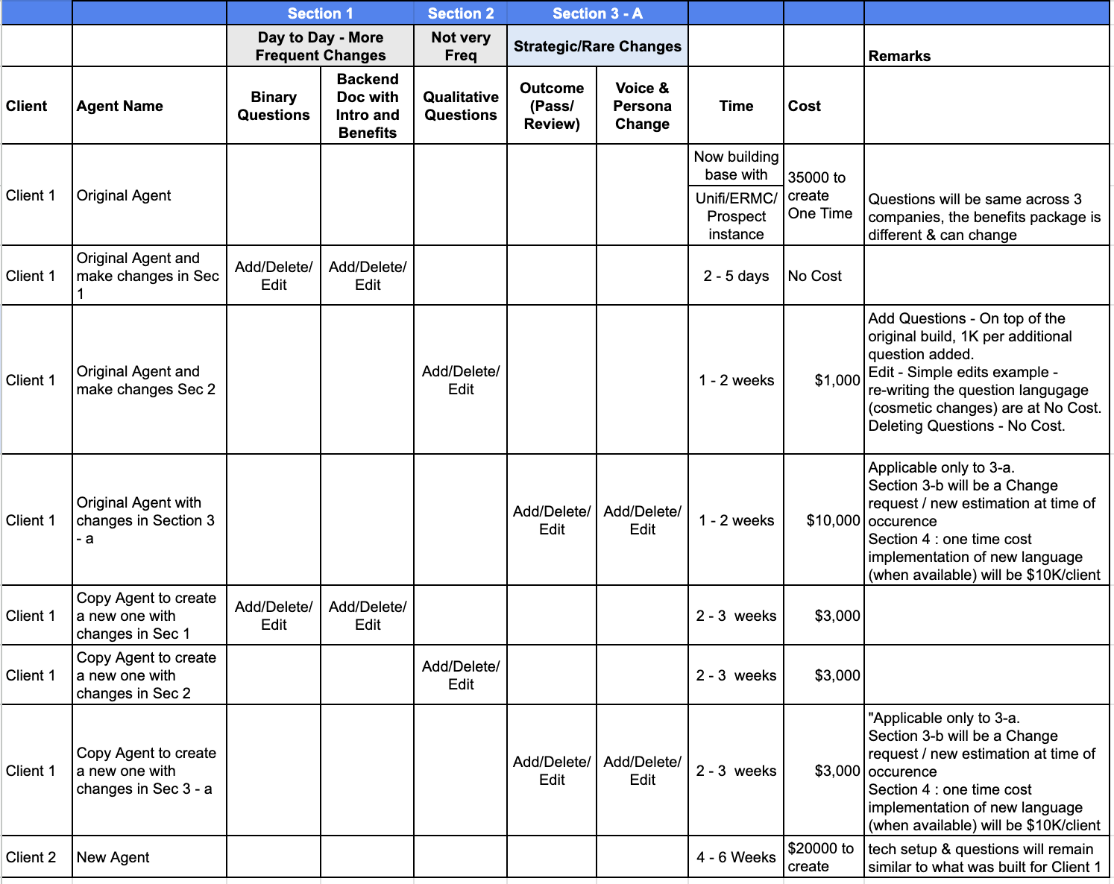

The following scenarios are not covered in the contract & to be discussed separately:
- Critical changes like implementation / rollout to a new country
- Critical changes like change of backend (from Avature)

